**Test Document for IR-13618- The vendor is not reflecting in pre and post order session**

In Session, dmisg1136m000(Evalute Vendor Document) Vender name is shown from master.

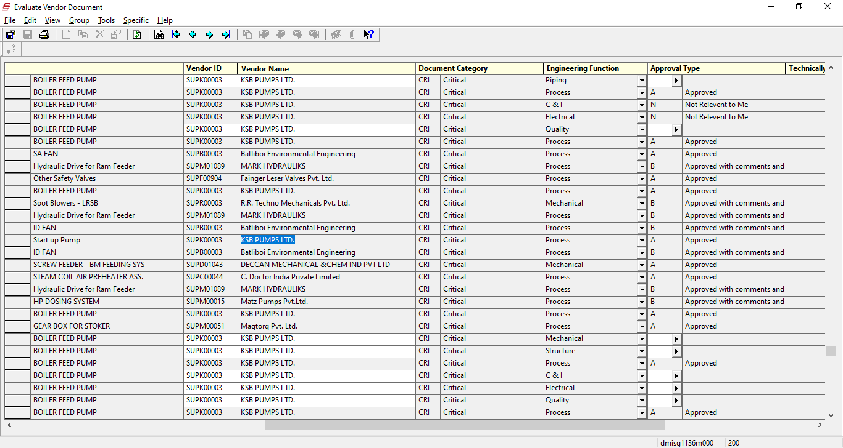

In Session dmisg1136m100 (Evalute Vendor Document – Post Order), Vender name is shown from master.

